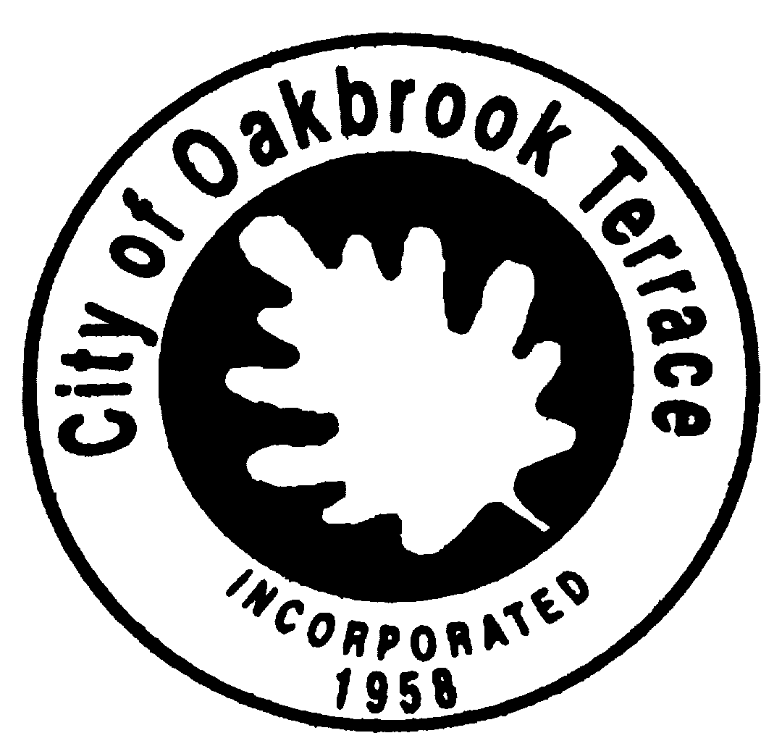
WARD 1
Alderman Charlie Barbari
Alderman Joseph Beckwith

WARD 2
Alderman Frank Vlach
Alderman Dennis Greco

WARD 3
Alderman Robert Rada
Alderwoman Mary Fitzgerald
MAYOR
Paul Esposito

CITY CLERK
Michael Shadley

CITY ADMINISTRATOR
Amy Marrero

CITY OF OAKBROOK TERRACE
17W275 BUTTERFIELD ROAD OAKBROOK TERRACE, IL 60181
630-941-8300 FAX 630-617-0036

REGULAR COUNCIL MEETING
AND COMMITTEE OF THE WHOLE

NOTICE
of
CANCELLATION

The City of Oakbrook Terrace
Regular Council Meeting
Scheduled for
Tuesday, December 28, 2021
At 7:00 P.M.
Has been Cancelled

